The Annual Report of *Churches Together in Bexhill as a CIO*, AD 2024

Registered Charity no. 1205042

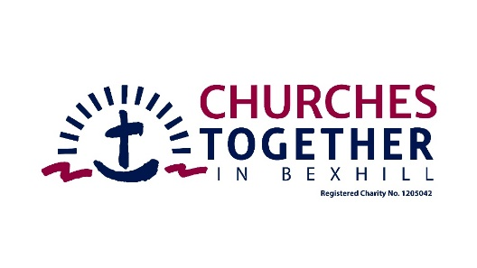

For its first AGM

on Wednesday 26th June, AD 2023 (following AGM at 7.30pm of CTiB as non-CIO)

at St Mark’s Church Hall, Green Lane, Little Common, Bexhill-on-Sea TN39 4TY

*Preceded by opportunity for people to enrol as members*

Agenda

1. Welcome

2. Apologies

3. Chairman’s comments

4 Matters arising

5 Financial Statement (since 1st April) – sent separately

NB Assets and responsibilities were transferred from CTiB charity number 1149860 on 31/3/24.

6 Appointment of Trustees (apportioning terms of up to three years to create an annual cycle of vacancies of a third) and Officers (Chair, Treasurer, Secretary)

7 Any other business

8 Questions

9 Prayer

This meeting has been prepared to comply with the requirements of the Charity Commissioners regarding the conduct of a Charitable Incorporated Organisation.

As stated in our Constitution of 19th August, 2023, CTiB as an CIO exists for

1. The advancement of the Christian Faith for the public benefit

2. To further such charitable purposes as are exclusively charitable and connected to the charitable work of the charity (in particular, but not exclusively, the relief of need in the community of Bexhill and Rother for those in need by reason of their youth or other social or economic disadvantage through the running of Foodbanks and community hub).